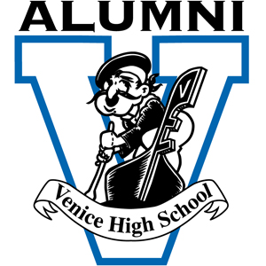

Venice High School Alumni Association Distinguished Alumni of the Year Award
Criteria

The Venice High School Distinguished Alumni of the Year Award was established in 1963 by the Venice High School Alumni Association to honor outstanding Venice High Alumni or Teachers/staff members who have earned significant distinctions and achievements.

Inductees are recognized in November with a special dinner in their honor and at the Venice High School Homecoming Football Game.

Nominations are welcome ANYTIME. Go to the Alumni Website: venicehighalumni.com and click on Alumni Annual Awards.

Nominations may be made by anyone for any graduate or teacher/staff from Venice High School. Nominees must have graduated from Venice High School ten years ago.
Teachers or school staff must have served Venice High School for 20 years. Nominees may be living or deceased.
The nominees must have realized distinctive achievements in their personal life or in their chosen field(s) that includes such areas as: business, education, science, medicine, law, military, public service community service, politics, entertainment, music, arts, athletics, philanthropy, religion or any other significant area of achievement.

The Venice High School Alumni Board of Directors will make the final selections.

All nominations submitted will be reviewed on an ongoing basis and remain on file with the Venice High School Alumni Association for future consideration.

The nominator is encouraged to attach supporting documents to the nominating form.

The VHS Alumni Board of Directors shall consider all nomination information confidential. Deadline for submitting a nomination for this year’s award will be June 1st.
Nominations must be submitted on the Venice High School Alumni Association’s Nomination form to:

Venice Alumni Association 2435 Walgrove Ave., L.A., CA 90066
Attention: Craig Jaffe - Alumni Awards Coordinator - craig@jaffeinsurance.com

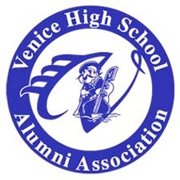
Venice High School Distinguished Alumni of the Year Award
Nomination Form

The Venice High School Distinguished Alumni Award recognizes and honors graduates and teachers/staff of Venice High School.

Distinguished Award Nominees must have graduated 10 years ago. Teachers and school staff must have served Venice High for 20 years.

Nominations may be submitted all year long to the Alumni Awards Coordinator, but no later than June 1st to qualify for this year’s award.

Nominee:
First MI Last Maiden Address:

Phone # E-Mail
Nominee’s Year of Graduation from Venice High School:

Educational Background Including Degrees Held:

Employment / Vocation:

Honors and Awards Received (Community, Professional, Military etc):

Professional Organization Membership/s:

Hobbies/Interest Areas:

Describe Why Nominee Should be
Selected:

Please attach any supporting material: Newspaper, Magazine articles, Photos etc.

Nomination Made By: Address:

Day and Evening Phone #’s
E-mail _________________________________
Date of Nomination:

This nominee’s information will be considered confidential by the Venice High School Alumni Association.

All Nomination Forms and any questions or comments should be sent to:

Venice Alumni Association 2435 Walgrove Ave.
L.A., CA 90066

Attention: Craig Jaffe - Alumni Awards Coordinator craig@jaffeinsurance.com

